Wyndham Youth Services

Youth Forum 2023 - Findings Report

The 2023 Youth Forum was held on Friday the 15 September 2023 at the Encore Events Centre in Hoppers Crossing with 122 young people registered to attend workshops on 3 main themes. The information and feedback collected will be used to inform services, programs, activities, and facilities for young people in Wyndham. The information will be distributed locally to residents, community support agencies, education providers and Council departments via this report.

CONTENTS Page
Executive Summary………………………………………………………………………………. | 2
Who attended the Youth Forum in 2023…..………………………………………….. | 2
Methodology………………………………………………………………………………………... | 3
Summary of Topic Feedback…………………………………………………………………. | 4
WELFARE ISSUES
Mental Health................................................................................. | 5
COMMUNITY ISSUES
Public Transport ............................................................................. | 8
Sports and Accessibility .................................................................. | 12
How The Findings Will Be Used……………………………………………………………… | 15

EXECUTIVE SUMMARY

In September 2023, Youth Services held their biennial Wyndham Youth Forum at Encore Events Centre with 56 young people between 12-25. The young people came together to participate in a range of workshops lead by youth services, young people, community agencies and staff from various Council departments. The Youth Forum aims to enable young people to have their say about key issues that affect them directly and is used to empower and inspire young people. The information and feedback collected will be used to inform services, programs, activities, and facilities for young people in Wyndham.
WHO ATTENDED THE YOUTH FORUM IN 2023

The 2023 Youth Forum was held on Friday 15 September at the Encore Events Centre in Hoppers Crossing. The breakdown of attendance is as follows.

Young People
- 122 Young people registered, and 56 people attended in person representing suburbs:
  - Werribee
  - Manor Lakes
  - Tarneit
  - Altona
  - Hoppers Crossing
  - Mambourin
  - Point Cook
  - Truganina
  - Wyndham Vale
  - Williams Landing

Youth Forum workshop facilitators:
- 6 Youth Services staff
- 1 Transport and Sustainability staff
- Sagalee Adem – Young Person MC
- Georgia Mihnjak - Artist

Wyndham Council – 7 from the following departments:
- Youth Services
- Transport and Sustainability

Special guests
- Wyndham Councillors
- Myr McIntyre
- Cr Barrera
- Cr Szatkowski
- Cr Maynard
- Cr Hill
- Cr Ramesh

Community services:
- Wyndham Community and Education Centre

The total number of people who attended the 2023 Youth Forum was 70.

METHODOLOGY
Each year, Youth Services holds the biennial Wyndham Youth Forum which brings together students and young people from around Wyndham including local secondary schools, community support agencies and staff from a range of Council departments. The Forum aims to provide local young people with an opportunity to:
- Provide feedback and advice to Council about issues that concern them;
- Engage with Council staff and local service providers; and
- Identify future directions for advocacy, projects and programs that can be actioned by Council, various youth committees and the combined Wyndham School Representative Council.

To ensure that the Forum was responsive to the issues affecting young people, young people were consulted prior to the event about the issues they felt had the most impact on the community. Key focus areas were identified through extensive consultation with young people who attended various youth programs and services, which was used to provide an outline of topics for the Forum.

On the day of the Youth Forum, the day was structured into three blocks of workshops. Each workshop contained 15-20 young people. Facilitating the workshops was a mix of youth workers, council staff, agency staff, and young people who had received workshop co-facilitation training.

Topics were categorised under 3 main topics: ‘Welfare Issues’ and ‘Community Issues’. Each interactive workshop covered core questions with the young people: what is the issue, how are young people connected to it, what are the challenges, what would they like to see done about it and any ideas they may have for solutions.

In their feedback about the day, students described the Youth Forum as a fun, interactive, inspiring and informative day. Specifically, they indicated that:
- They were able to put forward their opinions and ask questions in a supportive, non-judgemental environment;
- They liked meeting and working with young people
- The forum provided a great opportunity for them to speak directly to their Council; and
- They could contribute to positive change within their community.

The information and feedback recorded from the workshops at the Youth Forum resulted in a wealth of subject specific data which will be collated and distributed locally to residents, community support agencies, education providers, Council departments and professional networks via this report, and made available on the Wyndham Youth Services website.

SUMMARY OF TOPIC FEEDBACK
Discussion focussed on three areas: Connection, Challenges and Change:

MENTAL HEALTH
- Young people felt that there was a lack support from parents around this issue.
- Young people felt that it’s important to have healthy relationships with yourself and the people around you to maintain good mental health.
- Young people identified that cultural understanding of mental health is important.
- Young people feel that the stress of living can be hard to manage and contribute to poor mental health.
- Young people feel like there are a lot of gaps in services and long waitlists.
- Young people mentioned “system fatigue” which can be retraumatising.
- Young people felt they lacked confidence if trying to seek support.
- They feel that families and parents require education on the topic of adolescent mental health.
- They believed that younger people should be encouraged to learn about mental health to reduce stigma.
- They feel there should be an aim to reduce stigma around men’s mental health

PUBLIC TRANSPORT AND SAFETY
- Young people expressed frustration at the lack of accessible public transport options and the irregularity at which they ran.
- Public transport is a barrier to young people accessing Youth Services programs and events.
- Young people felt unsafe on public transport mainly busses and at train stations.
- Young people commented that they generally don’t feel comfortable or safe on public transport.
- They would like to see more bus stops in newer areas and places far from train stations.
- They want to see more access in Featherbrook, Manor Lakes and Saltwater, riverwalk estate.
- They would like it to reduce in price, as its too expensive, such as free mykis.
- They want to see more buses run later, and more express trains.
- They want to see buses run more frequently, and double decker buses at school times.

SPORTS AND ACCESSIBILITY
- Young people are concerned about the distance, accessibility and cost of some recreational services and activities.
- Young people enjoy sport and experience a lot of positive benefits, and it should be more available to young people.
- Young people expressed the need for public transport and bus routes to make recreational facilities accessible.
- Young people would like to see relevant services and facilities made more affordable.
- Young people expressed they would like to see more support for young people who need help joining clubs.
- They would like to feel safe in public spaces and suggested an increase in security, cleaning, and good lighting.
- Young people would like to see more equality in schools and the breakdown of gendered stereotypes for sports activities such as uniforms.

MENTAL HEALTH

The Issue:
- Young people identified that it’s important to feel heard when it comes to mental health.
- Young people outlined key areas that caused mental health concerns: Relationship and family problems, anger, bullying and peer pressure, isolation, learning difficulties, suicidal ideation, eating disorders, negative stigma, drug induced illnesses, and other mental illness.
- Young people felt that there was a lack support from parents around this issue.
- Young people felt that its important to have healthy relationships with yourself and the people around you to maintain good mental health.
- Young people identified the top three most prevalent mental health issues as being anxiety, depression, and stress.
- Young people identified that cultural understanding of mental health is important.
- Young people feel that the stress of living can be hard to manage and contribute to poor mental health.

Connection:
Young people acknowledged that everyone has a different connection to mental health, and some people have more understanding than others, but it was agreed there needs to be more awareness overall of the issue.
- Young people listed some personal lived experience of mental health such as overcoming trauma from domestic violence, working on coping mechanisms, difficulty within mental health systems, and other experiences based off cultural, gender, sexuality and diversity.
- Young people suggested it was important to keep an eye over friends who may be experience mental health issues.

Challenges:
One of the key barriers that prevent young people from accessing support services for mental health issues was a lack of awareness about the help that is available. Where they were aware of services, they identified the following issues regarding accessing them:
- Young people feel that there is a lack of parental or cultural acceptance of mental health issues which translates into a lack of support and trust or consent for the young person to access services.
- There is a perception that confidentiality will not be upheld by mental health support services.
- Time and cost are barriers that prevent young people from accessing support services.
- Young people may not engage with services because of the negative stigma around mental health which results in a fear of being judged or labelled, confrontation, and lack of acceptance.
- Young people experiencing a mental health issue often lack motivation to address the issue.
- Young people experiencing mental health issues may feel shame, denial, insecure, lack confidence and feel uncomfortable to seek help. They also hold concerns over being misdiagnosed.
- Young people feel like there are a lot of gaps in services and long waitlists, such as youth homelessness.
- Young people mentioned “system fatigue” which can be retraumatising.
- Young people felt that medication was dispensed to easily.
- Young people felt they lacked confidence if trying to seek support.

Change:
Young people believed that there should generally be more support, and more free services with shorter wait times, in safe spaces where younger people can open up and share.
- They feel that families and parents require education on the topic of adolescent mental health.
- They believed that younger people should be encouraged to learn about mental health to reduce stigma.
- Aim to reduce stigma around men’s mental health and encourage more male counsellors to work.
- They think Mental Health related education should be free, such as degrees etc

MENTAL HEALTH DATA

What do you think good mental health looks like?

- Good hygiene | - Enjoying time with yourself and others
- Talking and socialising more | - Communicating well
- Loving and caring | - Engaging with activities you like
- Feeling/looking great | - Feeling heard
- Sharing | - Passionate
- Trying new tings | - Dealing with things well
- Helping each other | - Able to relax and practice mindfulness
- Exercising | - Being joyful, positive and smiling
- Happy spending time alone  - Having access to positive environments  - Sleeping well | - Achieving goals  - Self-care  - Working on being a better version

What barriers are there to accessing mental health support in Wyndham?

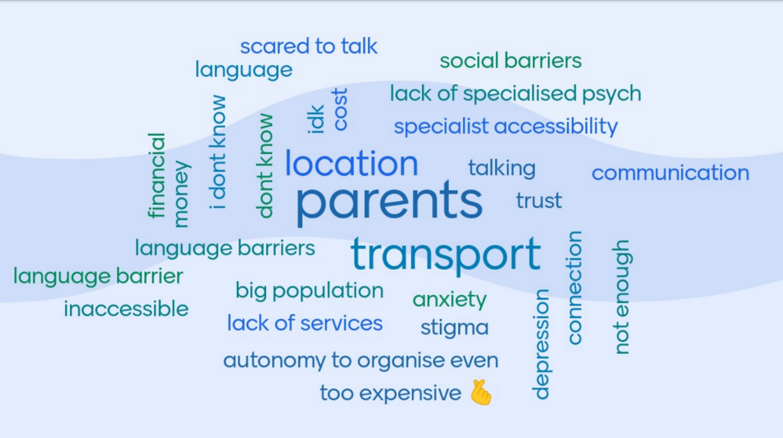

What do you know about accessing support?

70.37% of young people said they know how to access professional support
29.63% of young people said they did not know how to access professional support

What do you know about cost of accessing support?
- Too expensive | - Varies
- Unfortunately, expensive are better quality | - School support is free
- Free | - Insufficient Medicare rebate

What would you like to see more of in the community that would improve mental health and wellbeing?

- Easy processes | - Specialised support for men
- More/free programs | - Awareness
- Positive promotion of self-image | - Cheaper living circumstances
- Easy access to sport | - Better in-school programs
- Meeting other refugee young people | - Holiday programs
- Closer health centres | - Happy friends and Family
- Autonomy | - Increased subisidised specialist accessibility
- Sharing food | - Support when talking to family

What strategies do you use to improve your mental health?

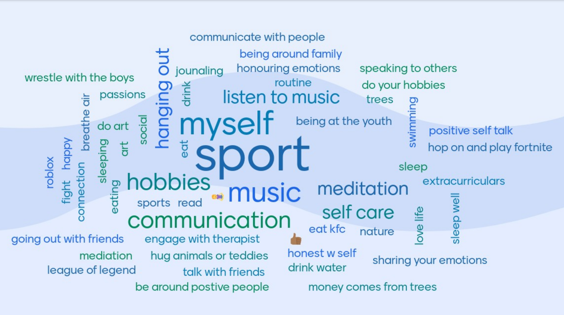

PUBLIC TRANSPORT

The Issue:
Young people discussed moving around Wyndham via public transport was difficult and prevented them from accessing youth specific recreational and support services.
- Young people expressed frustration at the lack of accessible public transport options and the irregularity at which they ran.
- Young people feel less safe when walking at night and would avoid it where possible, in areas where there is poor or faulty lighting.
- Public transport is a barrier to young people accessing Youth Services programs and events.
- Young people feel less safe catching public transport at night and would avoid it where possible.
- Young people felt unsafe on public transport mainly busses and at train stations. They perceived older train stations as feeling less safe than new stations, in particular Werribee and Hoppers Crossing Stations.

Connection:
Young people identified they use public transport often because:
- They don’t have a driver’s license, and they need to move around.
- Parents are too busy to drive them around.
- They need to get to work, the city, and school.
- They want to go to social events and support services.
Challenges:
- Young people commented that they generally don’t feel comfortable or safe on public transport.
- Young people say there are not many public transport options out of Werribee
- Public transport is not clean, and the bus drivers are rude.
- Tarneit station is too crowded.
- Bus stops rarely have seating.

Change (what needs to happen)?
- They would like to see more bus stops in newer areas and places far from train stations.
- They want to see more access in Featherbrook, Manor Lakes and Saltwater, riverwalk estate.
- They would like it to reduce in price, as its too expensive, such as free mykis.
- They want to see more buses run later, and more express trains.
- They want to see buses run more frequently, and double decker buses at school times.
- Young people think drivers should have more training in driving and dealing with people with disabilities.
- Change bus terminal locations they are in an awkward spot.
- More safety on public transport.
- Cleaner buses and bus stops, with more lighting.

PUBLIC TRANSPORT AND SAFETY DATA

Young people were asked if public transport prevents them from accessing youth-specific spaces:
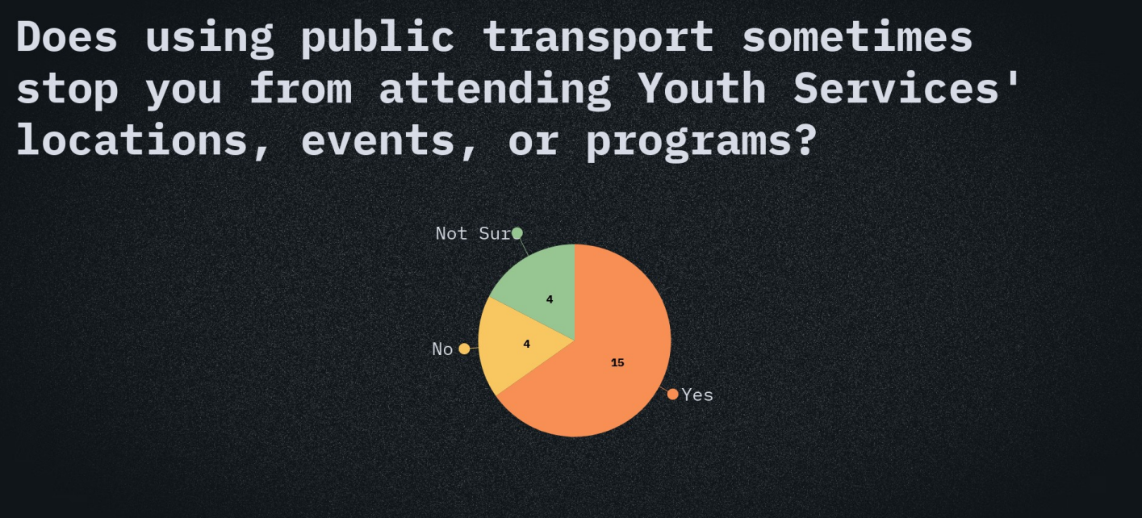

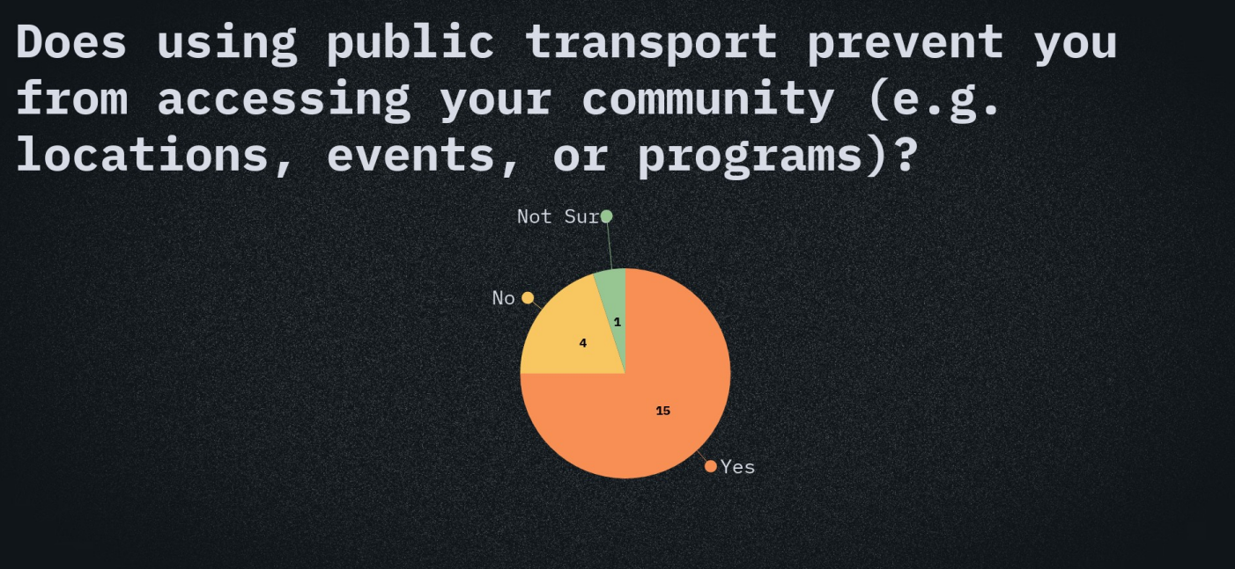
How could public transport and safety be improved?
- Reduce overcrowding | - Implement safe zones
- More supervision and security | - More lighting at bus stops
- Bus drivers trained to intervene | - School - specific buses
- More CCTV at the stations | - Update schedules more often
- Bus stops not near busy roads | - Safer driving
- Free or cheaper transport | - Cleaner buses

Young people were asked to rank these barriers to using public transport:
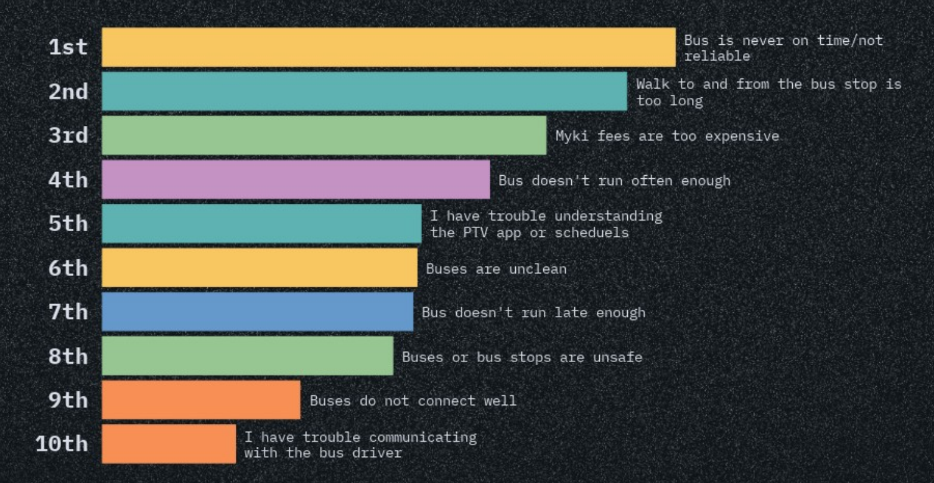
Young people were asked to rank these safety concerns:
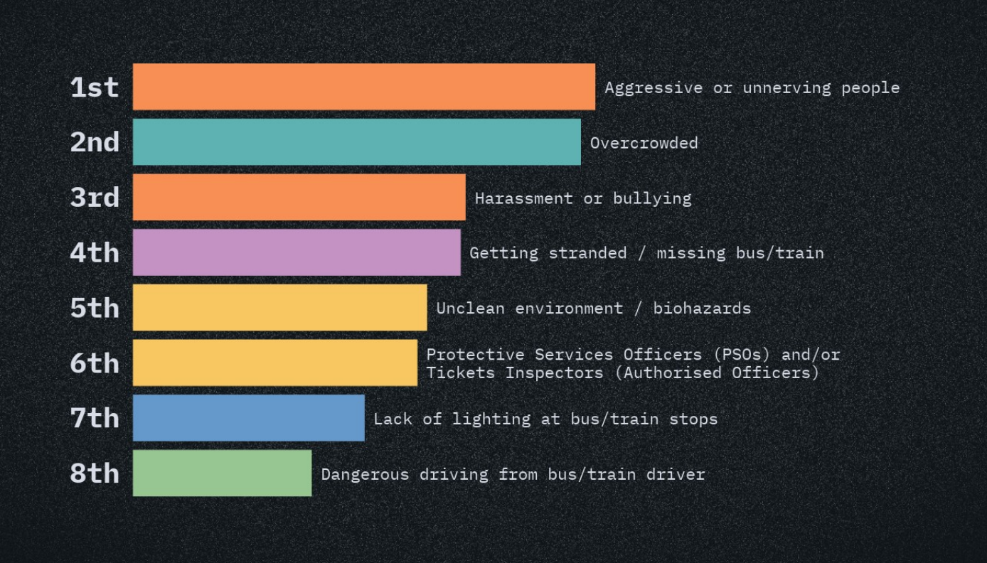

Young people were asked where they would build a new bus stop:
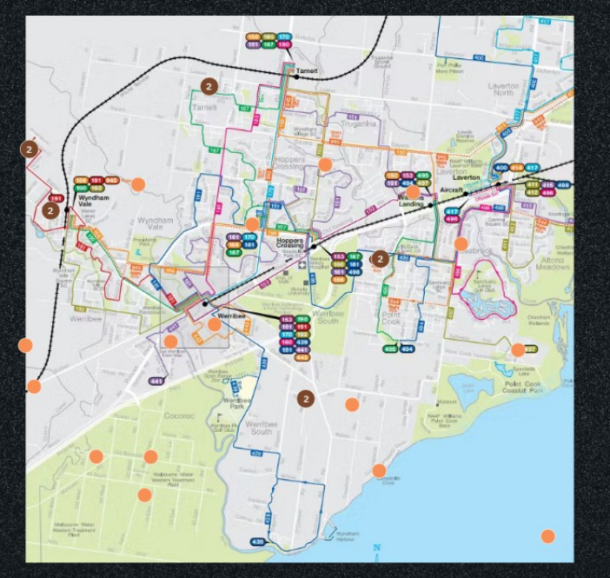

SPORTS AND ACCESSIBILITY

The Issue:
- Young people identified that volleyball, soccer, football, and basketball were very popular.
- Young people identified that while there were many recreational facilities around Wyndham, at times they were unable to be used due to overcrowding, transport and cost issues, or vandalism.
- Young people are concerned about the distance, accessibility and cost of some recreational services and activities.
- Young people enjoy sport and experience a lot of positive benefits, and it should be more available to young people.

Connection:
Young people have different connections to why they enjoy sports. Young people said they participate in sport because:
- They like to make friends and they feel included.
- They enjoy the team building environment.
- For fitness and to engage in exercise.
- They enjoy the competition.
- To have fun and be social
- To win and enjoy the competition.

Challenges:
- Young people identified that while there were many recreational facilities around Wyndham, at times they were unable to be used due to poor behaviour of teammates and coaches, overcrowding, transport and cost issues.
- Young people said they didn’t know what sport was available in Wyndham.
- Young people identified challenges with locations, time and days not being suitable.
- Young people expressed concerns over the cost of participating in recreational activities and associated costs (uniforms, registration)
- Other barriers included attitude from other players, parents, family issues, cultural beliefs, language barriers, public transport, feeling unsafe near train stations and bus stops (especially when travelling alone).

Change?
- Young people expressed the need for public transport and bus routes to make recreational facilities accessible.
- Young people would like to see relevant services and facilities made more affordable.
- Young people expressed they would like to see more support for young people who need help joining clubs.
- They would like to feel safe in public spaces and suggested an increase in security, cleaning, and good lighting.
- Young people would like to see more equality in schools and the breakdown of gendered stereotypes for sports activities such as uniforms.

SPORTS AND ACCESSIBILITY DATA

What barriers have you experience from trying to engage in Sport in Wyndham:

- Lack of confidence | - Hard to sign up to the club
- Not being able to pay for the club | - No cultural understanding
- Behaviour of teammates/Rough players | - Not fit enough
- Lack of venue/sport ground | - No motivation
- Parents unsupportive | - Parents too protective
- Not fitting in | - Transport
- Uniform fee | - Safety

Which of the following prevents you from participating in the sport you love:
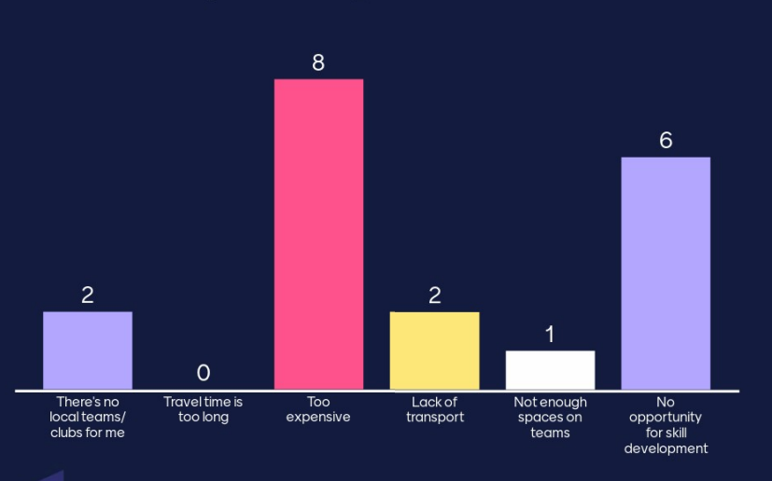
How would you improve access to sport in Wyndham:
- Lower cost | - Holding classes for people who need help
- More tournaments | - More supportive teams
- More clubs | - Coaches that are trained to care better
- More diversity | - Shuttles to pick up and drop off
- More facilities | - More multicultural events

The young people were asked to rank the barriers to accessing sports grounds:
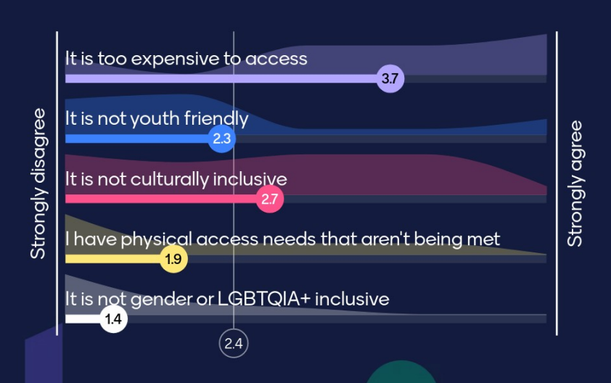

The young people were asked how they usually get to sports training/games:
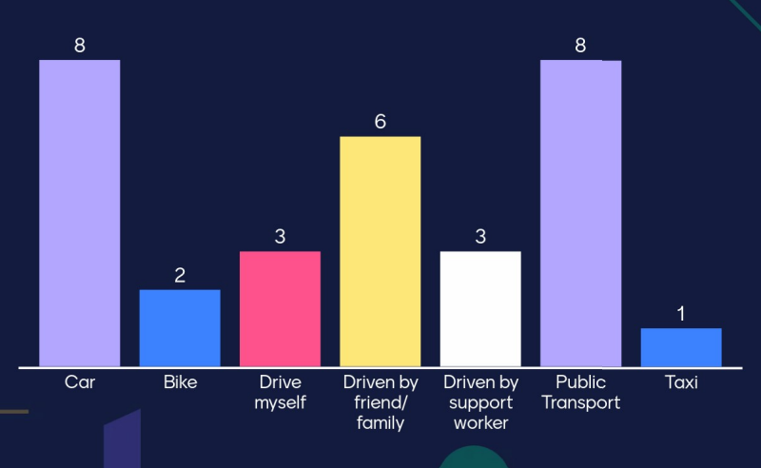

HOW THE FINDINGS WILL BE USED

The information and feedback recorded from the workshops at the Youth Forum resulted in a wealth of feedback and data which will be collated, distributed and used in accordance with the following process:

 |  | Youth Forum Findings Report
Distributed locally to:
- Residents
- Community support agencies
- Education providers
- Council departments
- Professional networks

Youth Forum findings feed into:
- Service planning and delivery
- Programs and events
- Wyndham Youth Plan

Youth Committees run by Wyndham Youth Services  - Youth Task Force  - Point Cook committee  - Wyndham Vale committee  - Tarneit Committee  - CALD Committee  - Vibes Committee  To develop community projects and events in response to feedback |  | Professional networks and working groups:  - Senior Youth Alliance  - Youth Mental Health Service Network  - Wyndham Workers with Young People Network  - Youth Portfolio Committee - to advocate for young people in the community with an emphasis on place-based delivery of services. |  | Combined Wyndham Student Representative Council (WSRC)  To collectively develop a school-based project in response to one issue or theme highlighted at the Youth Forum

A copy of the Findings Report and additional information is available on the Wyndham Youth Services website at INSERT LINK

For more information regarding the Youth Forum or findings, please contact Lucy Brownlie, Team Leader Youth Engagement and Projects at Wyndham Youth Services on (03) 8734 1355 or email lucy.brownlie@wyndham.vic.gov.au

