Preschool Field Officer Service

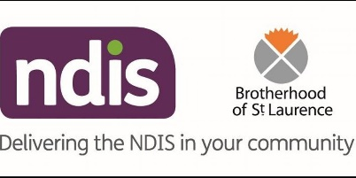  13 | EARLY CHILDHOOD APPROACH (NDIS)

In Wyndham, the Brotherhood of St Laurence (BSL) in conjunction with the National Disability Insurance Agency (NDIA) delivers the Early Childhood Approach (ECA) service.

ECA services support children 0-6 years with either a developmental delay or a severe disability in Western Melbourne. More information about this service can be found at:
https://ourguidelines.ndis.gov.au/early-childhood/early-childhood-approach

A diagnosis is not required in order to refer to the ECA, one or more areas of significant delay in a child’s development is all that is required (this can be in any developmental area).

WHAT IS THE EARLY CHILDHOOD APPROACH (NDIS)?

The ECA is designed to promote learning, development, wellbeing and participation in the community. This is done in partnership with the family, and any key people in the child’s life e.g. their Teacher/Educator.

This is a FREE service.

The ECA support aims to:
- promote the child’s learning, development and ability to participate in family, early childhood education and care settings and broader community life
- Assist parents and families to have the knowledge, skills and support to respond to the needs of their child

ECA support can be delivered by a range of professionals with specialist qualifications who apply their knowledge and expertise to support children to learn and develop. The professionals supporting a child may include:

Occupational therapist– Their specialist knowledge can contribute to supporting the development of a child’s independence in everyday activities including eating, dressing, toileting and a range of activities that are part of family life.
Physiotherapist- Contributes to supporting a child’s development in the areas of movement, posture and balance.
Speech pathologist – Will work in supporting a child who has difficulties talking, understanding speech, stuttering, eating and drinking, swallowing or drooling.
Psychologist– Can assist families to support a child’s social, emotional and overall development. They can provide advice and assistance to families including offering behaviour management guidance.
Specialist Early Childhood Educators– Educators who are trained in early years education and often special education. Educators are often part of ECEI teams and assist families to understand their child’s needs and to provide opportunities and experiences that support their learning and development.

WHO PROVIDES EARLY CHILDHOOD APPROACH SERVICES IN THE WESTERN REGION?
The NDIS has engaged Early Childhood Partners around Australia to deliver the ECA approach. Early Childhood Partners are experienced in providing early childhood intervention. The Brotherhood of St Laurence is the Early Childhood Partner for Wyndham and their contact details are:

The Brotherhood of St Laurence
Level 1, 236 Hoppers Lane, Werribee
Tel – 1300 275 323
Email – ecei.access@bsl.org.au

HOW DOES IT WORK?
Educators, families and others can contact the Brotherhood of St Laurence (BSL) if there are concerns about a child’s development. BSL can help you to get information and access to supports.

Families are provided with ideas on ways to help their child with their everyday living, learning and development.

As every child is different, the Brotherhood of St Laurence will tailor support to your child’s individual needs and circumstances.

The ECA team will:
- suggest which supports can best help the child and family. This could mean support from a general practitioner (GP), community health service or the National Disability Insurance Scheme (NDIS)
- work with the family to find ways to support the child’s development and learning at home
- help the family apply for the NDIS if needed

The referral form can be completed online or on paper. This can be found at:
https://ndis.bsl.org.au/early-childhood-early-intervention/referral-form/

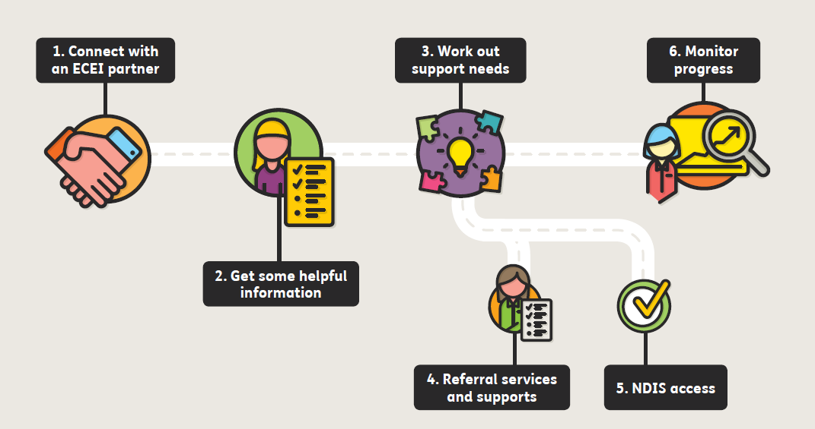

WHO CAN REFER TO ECA?
- Early Childhood Educators (with parent permission)
- Parents
- Other service professionals (with parent permission), such as MCH Nurses, GP’s, PSFOs.

EARLY CHILDHOOD APPROACH CONTACT DETAILS:

The Brotherhood of St Laurence
Level 1, 236 Hoppers Lane, Werribee
Tel – 1300 275 323
Email – ecei.access@bsl.org.au

USEFUL LINKS:

NDIS ACCESS CHECKLIST: CHECKLIST

REFERRAL FORM: https://ndis.bsl.org.au/early-childhood-early-intervention/referral-form/

NDIS4KIDS site: https://www.ndis4kids.org.au

