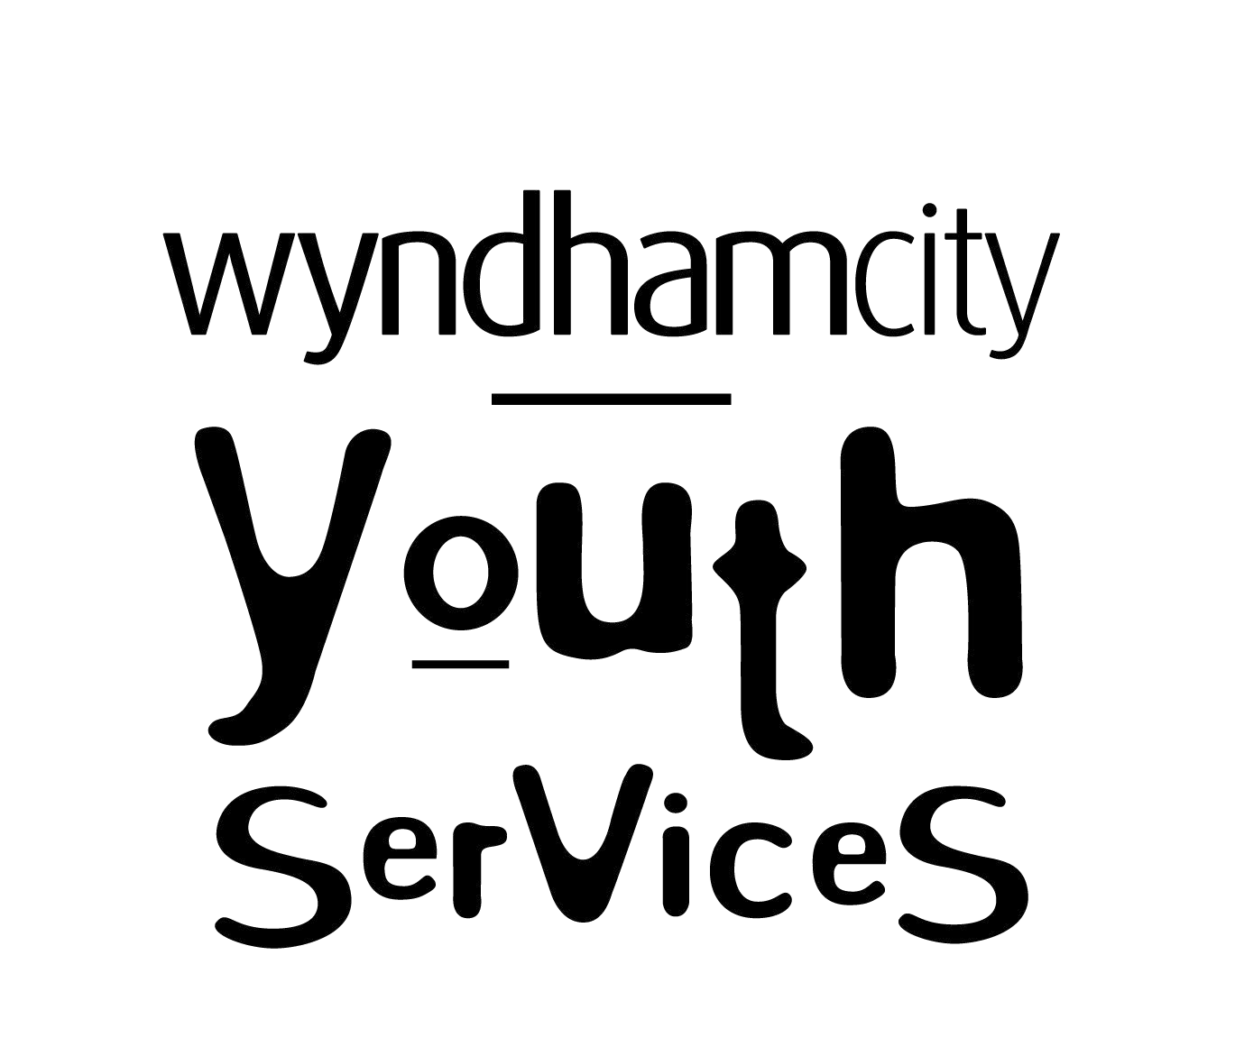
Enrolment Form

Personal & Confidential
Youth Services
This form is to be completed for Recreational Programs, Personal Development Programs & Committees.

Program De | tails | (for more information about the program, please contact Youth Services on 8734 1355)
Program Name, Term, Year
Young Persons Details
TITLE(Mr, Mrs,  Ms, Miss) | SURNAME/FAMILY NAME |  | GIVEN NAME | MIDDLE NAME |  | PREFERRED NAME
ADDRESS
EMAIL
PHONE NUMBER
AGE |  |  | DATE OF BIRTH / /
Gender (optional)
Internet Café
Do you intend to use the Youth Services Internet Café at the Youth resource Centre or Youth Services @ Point Cook? If yes, please sign under item Consent, Acknowledgement and Arrangements. |  |  |  |  | Yes  | No 
Internet Café Terms of Use Conditions
The user acknowledges and agrees that:
- The user will not use the computer facilities to:
  - Access, view or download and inappropriate or illegal content;
  - Engage in any illegal activity (such as pirating music or movies);
  - Send emails, messages or other electronic communications which are excessively large, unsolicited, unwanted, obscene, spam, or are intended to harass another person; or
  - Attempt to crash or interfere with any computer, by way of viruses, malware, denial of service attacks or otherwise.
- The user is responsible for abiding by all laws (including copyright and censorship) whilst using the computer facilities.
- Council is not responsible for any content accessed by the user whilst using the computer facilities.
- Council may impose session time limits upon users to ensure equitable and fair access to the computer facilities.
- Council does not guarantee the availability or response time of internet or any sites at any time.
- If these terms of use are breached, the user’s computer access may be suspended or terminated.

Internet Café Consent, Acknowledgement and Agreements
- I consent to the user accessing computer facilities via Council’s Youth Services from the date of signing this form until 31st December each year.
- I acknowledge and agree that the user will abide by the terms of use when accessing the computer facilities and that in the event of a breach of these terms of use, the uses computer access may be suspended or terminated.
- I acknowledge and agree that the user accesses and users the computer facilities at their own risk and I agree to indemnify Council, it’s Councillors, Staff, Volunteers, Contractors and Agents from and against any claims, losses, demands, damages, penalties and costs (including legal costs) arising from the user’s access and use of the computer facilities by the user.
- I understand that I may revoke this consent at any time by notifying Council in writing.
- Where I have provided parental/guardian consent, I confirm that I am the parent or legal guardian of the participant named on this form.
Cultural Diversity
Is the participant of Aboriginal or Torres Strait Islander descent? |  |  | Yes  | No 
Does the participant require an interpreter? |  |  | Yes  | No 
If YES, what language interpreter is required
Does the participant have any cultural requirements? |  |  | Yes  | No 
If YES, please specify.
Does the participant have any power of attorney arrangements in place? |  |  | Yes  | No 
If YES, please specify.
Participant’s Medical Information
Doctor’s Details | Name
 | Address
 | Phone Number
Health Insurance Details (if applicable) | Fund Name
 | Member Number
Medicare Number
Ambulance Member Number (if applicable)
Does the participant have any medical conditions, allergies or take any medication?  e.g. Asthma, allergy, epilepsy, medications? |  |  | Yes  | No 
If YES, please provide details below. A Medical/Health Information and Action Plan Form MUST also be completed.
Does the participant have any additional or complex needs or a disability? |  |  | Yes  | No 
If YES, please provide details below. A Supplementary Information Form MUST also be completed.

Parent/Guardian details (where user is aged under 18)
TITLE(Mr, Mrs,  Ms, Miss) | SURNAME/FAMILY NAME |  | GIVEN NAME |  | MIDDLE NAME |  | PREFERRED NAME
RELATIONSHIP TO PARTICIPANT
ADDRESS
EMAIL
PHONE NUMBER
Emergency Contact
TITLE(Mr, Mrs,  Ms, Miss) | SURNAME/FAMILY NAME |  | GIVEN NAME |  | MIDDLE NAME |  | PREFERRED NAME
PHONE NUMBER
RELATIONSHIP TO PARTICIPANT
Pick Up Arrangements (where the participant is aged under 18)
Is the participant allowed to leave the program alone? |  |  |  |  |  | Yes  | No 
If NO, who is authorised to collect the participant from the program (in addition to the parent/guardian stated above)?
TITLE(Mr, Mrs,  Ms, Miss) | SURNAME/FAMILY NAME |  | GIVEN NAME |  | MIDDLE NAME |  | PREFERRED NAME
PHONE NUMBER
RELATIONSHIP TO PARTICIPANT
LEGAL ARRANGEMENTS
Other
Swimming Level |  | Please indicate the participant’s swimming ability. |  | non swimmer  Intermediate  experienced
Movie Rating |  | What rating do you approve the participant viewing in a movie or entertainment. |  | PG  M  MA 
Privacy Collection, Use and Disclosure Statement
Your personal and health information is being collected by Council for the purposes of you consenting to your or (your child’s) attendance at Youth Services Recreation Programs, Personal Development Programs and Committees:

- To consent to the use and disclosure of information to Council Staff involved in the Programs;
- To ensure young people are supported during specific program and general service delivery;
- Ensure parents/grandparents/guardians/workers or emergency contacts can be easily contacted if required;
- Assist Youth Services with strategic program and service planning, delivery and evaluation.
- Create an opportunity to provide you with promotional material about the services and programs

Your information will be stored in Council’s Customer Database and used to identify you when communicating with Council and for Council to deliver services and information to you.

The information you provide shall remain private within Council unless disclosure is permitted by law, or consented to by you. You may apply for access and/or amendment of the information by writing to the Council’s Privacy Officer.

For further information on how your personal and health information will be handled, refer to Council’s Privacy Policy at: www.wyndham.vic.gov.au/privacy-policy

It is assumed that all emergency contacts listed have been notified and have given permission for their details to be provided. Youth Services staff shall enter this information into a database for data collection.
Consent, Acknowledgments and Arrangements
- I consent to the participant taking part in this service.
- Fieldtrips and excursions are part of program delivery and will operate under normal supervision and program guidelines and may involve walking or being transported by Council buses/cars to venues inside the municipality.
- In the event of misbehaviour or behaviour that poses a danger to the participant or others during the program, I acknowledge that the participant may be sent home at my expense and I will be notified about this.
- If the participant becomes ill or suffers an injury during the program and I cannot be contacted, I consent to the participant receiving first aid and emergency medical treatment (including transport to hospital by ambulance) as may be deemed necessary by the Council.
- I acknowledge and agree if the participant is not picked up at the pick-up time specified, I will be charged a late pick-up fee at a rate of $5.00 per 5 minutes until such time as the participant is picked up.
- I acknowledge and agree that any personal items brought to the program by the participant are the responsibility of the participant and that Council takes no responsibility for any personal items which are lost or stolen.
- I acknowledge and agree that the participant attends the program at their own risk and I agree to indemnify Council, its Councillors, Staff, Volunteers, Contractors and agents from and against any claims, losses, demands, damages, penalties and costs (including legal costs) arising from the participant’s attendance at this program.
- I acknowledge and agree that Council reserves the right to cancel or alter the program.
- I agree to notify Council in writing of any changes to the information I have provided in this form or the participant’s ability to participate in the program as soon as is practicable.
- I agree that the emergency contact has been notified and has consented to their personal information being provided.
- Where I provided parental/guardian consent, I confirm that I am the parent or legal guardian of the participant named above.
Young Person Over 18 |  |  |  |  | Young Person Under 18 – Parent Signature |  | Internet Café ONLY (Over 16)
Signed: |  |  |  |  | Signed: |  | Signed:
Print Name: |  |  |  |  | Print Name: |  | Print Name:
Date: / / |  |  |  |  | Date: / / |  | Date: / /
Find out more!
If you are interested in learning about the services offered by Youth Services, visit our website at www.wyndham.vic.gov.au/services/youth-services, call us on 8734 1355 or visit us at the Youth Resource Centre (86 Derrimut Road, Hoppers Crossing).
Promotion
How did the participant hear about Youth Services |  |  |  |  |  | Friend  School  Youth Worker  Family  or Other
Would you like to receive promotional information on Youth Services? |  |  |  |  |  | Yes  |  | No 
Office use only
NAR  □ | CRM  □ | Scanned  □ | Filed in CRM □ | Objective  □ | Provided young person with additional information if indicated from the ‘Services and Programs’ section  □

