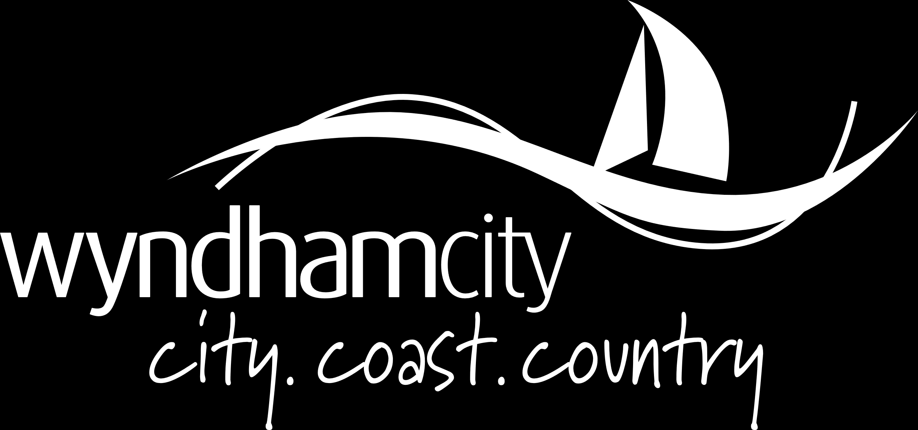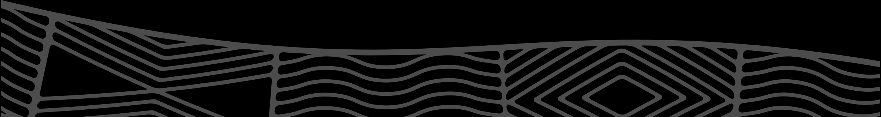

September 2024

Penrose Promenade Community Centre Mural Project

# Penrose Promenade Community Centre Mural Project Expression of Interest –FAQ’s

# Who can apply?

Joint applications may be submitted from partnerships or collectives, however there will only be one artist fee available for each individual artist or collective per submission. To be selected for this site the Artist or Collective must:

* Live or work in, or have a connection to, Wyndham City.
* Hold a valid ABN and have work rights for Australia
* Be able and willing to complete the artwork design before early January 2025. If installing, be able and willing to complete the installation by the end of February 2025.

Expressions of Interest are strongly encouraged from First Nations people, people with disability and people from underrepresented cultural and linguistic backgrounds.

# How are the EOIs assessed in terms of making a shortlist of 3x (three) Artists/Collectives?

The EOI’s will be assessed by a panel of Wyndham City Council representatives and external stakeholders.

They will be assessed in terms of:

* The Artist or Collective’s previous body of work in relation to how it might apply to the project.
* The Artist or Collective’s ability to understand and interpret artistic themes and cultural knowledge based on previous relevant experience, knowledge or responses provided.
* Perceived ability to communicate ideas effectively and liaise with project stakeholders.
* Perceived ability to work within the timelines of the project.

# Do I need experience as an artist to submit an EOI?

Having a certain level of experience is not a pre-requisite for submitting an EOI, however, the artists shortlisted will be perceived as capable of developing a design to a high standard and required format, including further design development with feedback, and liaison with an installation company if/as required to ensure that the design is accurately represented in the final mural.

# What do I need to submit for the EOI?

The Artist or Collective will need to submit a short bio and up to 3x examples of their work in accepted image formats: gif, jpg, png, tif, pdf. No specific resolution is required; however, the max upload size is 10mb and successful applicant may be required to provide additional visual information or details upon request.

* Photographs and other visual art forms can be submitted.
* Abstract artwork will be considered
* Video applications will not be accepted.
* Hard copies of applications may not be submitted. Applications will need to be submitted via the online portal.
* Wyndham City Council commits to repairing any damaged artwork for the duration of the artwork’s lifespan.

# What are the fees for this project?

Artists will receive an artist fee for the successful work submitted and installed at the site. Three shortlisted artists will receive a $500 design fee. The final appointed artist will receive $3800 workshop, design & licensing fee. If the artist is not installing the work, an extra fee of $200 will be paid for communicating ideas to installers. If the artist is installing, there is an extra allocation of funds for the artwork installation. This will be discussed with the appointed artist and may be contracted out by the project working group if required.

# Do I / can I respond to the artist brief as part of my EOI submission?

No. The EOI submission is to assess artists who might be best suited to this project. The brief is made available to view (below) to give interested artists/collectives an understanding of the project including timelines, levels of commitment and other information.

# Will I be painting the mural myself?

Not necessarily. Installation will be completed by a separate artist contractor unless otherwise agreed with the artist. The artist does not need to be present onsite during installation but will need to liaise with the installation team on the translation of the work from design to installation.

# Who owns copyright of the final artwork?

The ownership and title of the actual physical mural artwork will pass from the Artist to Council at the date the mural is installed and handover of the artwork to Council is complete. The mural artwork will and be maintained and cared for as part of Council’s growing public art collection. However, the copyright and any intellectual or cultural property contained in the artwork itself remains with the artist.

# How long is the licensing of the work and is it an exclusive license?

The artwork will be licensed from the artist by Council, this will be finalised in a written agreement with the artist. The licence will be an exclusive, perpetual and royalty-free licence for the artwork to be exhibited at the site of the mural and online on Council’s website and included as part of Council’s public artwork database on Victorian Collections digital archive. Any use outside promotional or educational material will require the artists express written permission.

# Will my information and artwork be kept Confidential and Private?

Yes. At Council we understand the need for individual privacy. Nothing that you submit will be made available to the general public without your express permission and prior written agreement.

# Will the shortlisted artists be obligated to participate in media calls and other initiatives to promote the project/mural?

As this is a public mural project, it is expected that there will be a small amount of press promotion surrounding the project. The final selected artist will be expected to participate in these opportunities to discuss and further platform their work, but it can be discussed with Council if they prefer to appoint a representative or spokesperson for this if they are not comfortable with this process.

# Consideration of the context

Submissions which add positively to Wyndham City and consider the history, community, and unique qualities and assets of the local area will be highly regarded. All other visual art interpretations will be considered.

If you are using Aboriginal or Torres Strait Islander stories or cultural material that is not your own, please provide evidence of community consultation and cultural permissions in the Support Material section of your application.

# How will my artwork be acknowledged at the site?

An attribution information plaque noting the artist, and the work will be displayed on site. The images of the artwork may be used to promote the artist’s work, and the artist will be acknowledged in relevant marketing or promotional material specific to this project.

# If successful, can I share images of my installed artwork?

Yes, you can share images of your artwork once the final artwork has been installed and approved by Council.

# What format will I need to use to submit my EOI? Will My artwork be cropped?

Your artwork may be cropped to allow for successful installation. Council will work with the final artist to communicate their design for the mural installation.

# Is there anything that I can’t include in my artwork?

The artwork must not:

* Be offensive to the general public
* Condone or provoke anti-social behaviour
* Promote or relate to alcohol or gambling
* Use sexualised images or gender objectification
* Portray images or events that may cause distress to children
* Be used to promote a political party, parties or a political cause
* Use offensive language
* Demean any person or group on the basis of ethnicity, nationality, race, gender, age, sexual preference, religion or mental or physical disability or
* Disparage or diminish the reputation of Wyndham City Council
* Include any commercial content
* Resemble, be capable of confusion with, or obstruct directional or informational signs or otherwise compromise wayfinding in any way
* Have large areas of block colour (reduces risk of graffiti)
* Include logos, overt branding or QR codes
* Appear to look like graffiti

# What support is available for artists with disabilities?

Applicants with disabilities can contact Arts Access Victoria (AAV) for application support at info@artsaccess.com.au or phone (03) 9699 8299.

# Who can I contact if I have any specific questions not covered in this document?

Please contact:

Yi Li

Public Art Support, Wyndham City Council

Yi.li@wyndham.vic.gov.au